**Attire: What to wear?**

▪ Students are required to wear a leotard each day.

▪ No shoes required.

▪ Shorts, tights, form fitting t-shirts are permitted.

▪ Hair is to be pulled back away from the face.

**What to bring?**

* Small snack
* Water bottle
* Extra Hair Tie

## What is the GDC

## Tumbling Clinic?

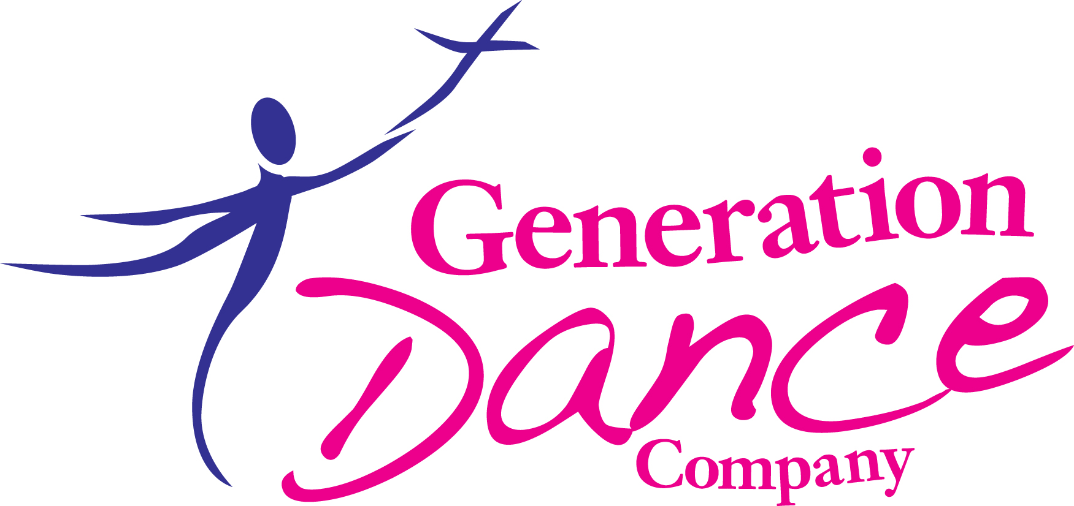

The Generation Dance Company (GDC) Tumbling Clinic is created for dancers and gymnasts with some tumbling or acrobatic experience. This program is designed to improve flexibility, strength, endurance, balance, and skills at all levels to help bridge the gap over the summer months. Students should come expecting to work hard and have fun!

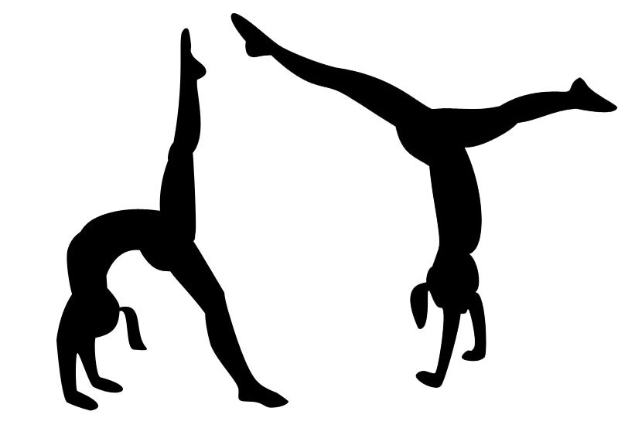

**SUMMER 2016**

**TUMBLING CLINIC**

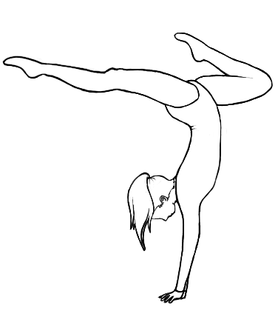

**2016**

June 20 – June 24, 2016

Email:generationdance@zoominternet.net

Phone: 330-519-8537

Web site: GenerationDanceCompany.com

Registration Form

(please detach flap and submit with payment)

Dancers Name:_____________________________

Age:______________________________________

Parent #1:_________________________________

Parent #2:_________________________________

Phone #:__________________________________

Email:____________________________________

|  |  |  |  |  |
| --- | --- | --- | --- | --- |
| Sign Up for: | | Time |  | Price |
| ❒ | Level 1 & 2 | 9:30-  11:45am |  | $85.00 |
| ❒ | Level 3 & 4 | 12:30-2:45pm |  | $85.00 |
| *$10 Discount available if enrolling more than one child. | | | | |

**Liability Disclaimer:** I for myself and/or my minor child release and forever discharge and agree to hold harmless Generation Dance Company for any liability, claims or demands for personal injuries, sickness, or death, as well as for expenses due to loss or damage to personal property or lost wages. Since dance is a physical activity, injuries may occur. Each student/guardian has the right to decline participation in any activity which they are not comfortable with or which they feel may be harmful. Each student/guardian is fully responsible for any injuries or harm occurring before, during or after a class at Generation Dance Company. Student/guardian is also responsible for informing instructor(s) of any physical limitation which may prevent full participation in class. If injury occurs, it is understood that the student’s own insurance policy is the only source of reimbursement. Additionally, Generation Dance Company has permission to use photos/videos taken of the above signed student for advertising, sales of media from dance shows and for any promotional purpose.

**Parent/Guardian must sign below in agreement with all terms of liability disclaimer & policies.**

**Signature:__________________________**

**Date:______________________________**

PARENT/GUARDIAN: Please provide all pertinent information regarding child including any special needs, safety concerns, medical conditions, allergies, or family issues. All information will be kept confidential.

_________________________________________________________________________________________________________

Checks made payable to: Generation Dance Company

Payment is due with Registration Form

**June 20, 2016 – June 24, 2016**

**LEVEL I & 2**

**9:30am-11:45am**

Students 6-12 years of age. Beginner to Intermediate level. These students should have some experience bearing weight on their hands.

Level 1 & 2 skills of focus are:

Front/Back & Dive roll, Handstand, Bridge, Backbend, Backbend Kickover, Cartwheel, Roundoff, Front Limber

***Instructor: Kimberly Walker***

*SPACE IS LIMITED. IF INTERESTED, REGISTER EARLY FOR PLACEMENT.

**LEVEL 3 & 4**

**12:30-2:45pm**

Students 7 to 14 years of age. Intermediate to Advanced level.

Required skills mastered to enroll:

Backbend, Backbend Kickover, Dive Cartwheel, Roundoff, Dive roll, Handstand, Plank, Front Limber.

Level 3 & 4 skills of focus are:

Front and Back Walkover, Front and Back Handspring, Aerials, and Tucks.

***Instructor: Kimberly Walker***

*SPACE IS LIMITED. IF INTERESTED, REGISTER EARLY FOR PLACEMENT.

15 minutes – Cardio Warm-Up, Verse & Prayer

15 minutes – Stretching

15 minutes – Strength Focus

15 minutes – Group Skill Focus

15 minutes – Break

(Can bring a small snack)

30 minutes – Stations

15 minutes – Group Traveling/Strength Skills

15 minutes – Open Tumbling

# Daily Schedule

## Dates, Times, & Levels

